USE-CASE CONTENT PACK | ZYKL FOR EVERY KIND OF FOCUS
One timer. Seven ways to use it.
Eight carousel posts (24 slides in English and Bahasa Indonesia) that show how ZYKL fits reading, studying, coding, writing, creative work, language learning and admin. Each post has room for your real screen recording as the first item. Every caption fits Threads' 500-character limit.

1. The idea
People don't search for a 'focus timer'. They search for a way to read more, finish an assignment or ship a feature. Showing ZYKL inside those moments helps new people picture themselves using it. Each post gives a concrete setup to try: a preset, a free soundscape and a sample slip.

The setups at a glance
Activity | Preset | Sound (all free) | Sample slip
Reading | 50/10 | Library Atmosphere | Read 20 pages
Studying | 25/5 | Lo-Fi Rain | Outline, Draft section 1, Review notes
Coding | 50/10 | Deep Brown Noise | Fix login bug, Write the test, Open the PR
Writing | Custom 40/8 | Warm Tape & Felt Piano | Write 300 words
Creative work | Custom 45/10 | Debussy, Clair de Lune | Explore 3 layouts
Languages | 25/5 | Kyoto Bamboo Stream | 10 new words, Say them out loud
Admin and chores | 15/3 | Monastic Cello Solo | Reply to 5 emails, Pay bills, Tidy desk
These are suggestions, not rules or productivity claims. The captions say 'I'd try' and 'my pick' on purpose. All the sounds named here are among the 8 free ones, so anyone can follow along.

2. How to post the series
- One carousel per week, in place of the Tuesday focus tip from your always-on plan. Eight weeks of material.
- Suggested order: the overview first, then coding and studying (your audience skews that way), then the rest.
- Alternate languages week to week, or post the Indonesian version a few days after the English one with a new hook. Never post both on the same day.
- One topic tag per post. A tag that matches the activity (coding, reading, studying) can help the right people find it.
- Reply to every answer to the closing question. The question is the point of the post.

3. The posts
Upload the three slides in order, with your video as the first item once you have it.

Post 1: Overview: one timer, every kind of focus
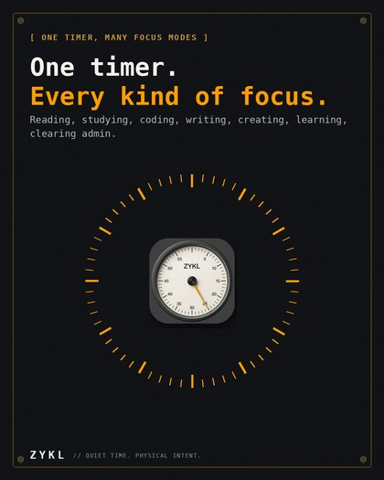  Slide 1: 00_overview_1_cover.png | 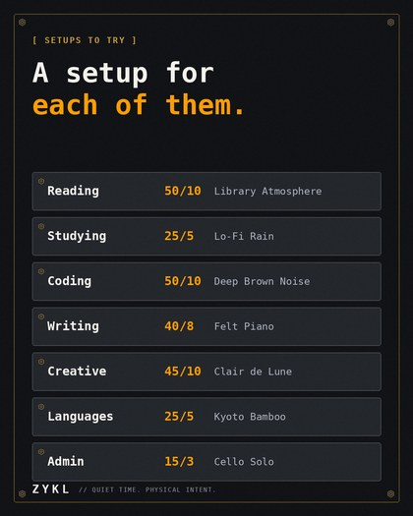  Slide 2: 00_overview_2_setups.png | 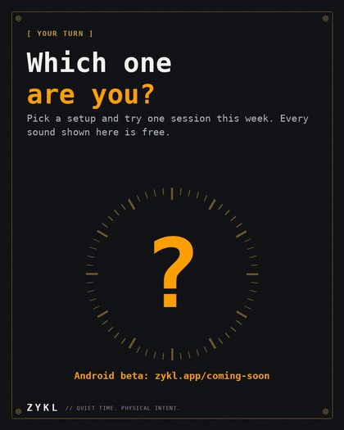  Slide 3: 00_overview_3_your_turn.png
ENGLISH  One timer, many kinds of focus.  Reading, studying, coding, writing, designing, practicing a language, clearing the boring admin: ZYKL fits all of them. Pick a preset, pick a sound, write up to 5 tasks, and start.  Swipe for a setup I'd try for each. Which one are you? | BAHASA INDONESIA  Satu timer, banyak jenis fokus.  Membaca, belajar, coding, menulis, mendesain, latihan bahasa, menyelesaikan urusan administrasi yang membosankan: ZYKL cocok untuk semuanya. Pilih preset, pilih suara, tulis maksimal 5 tugas, lalu mulai.  Geser untuk lihat setelan yang akan kucoba untuk tiap aktivitas. Kamu yang mana?
VIDEO TO ADD (FIRST ITEM OF THE CAROUSEL)
A 20-second montage: the dial ticking, switching presets 50/10 then 25/5 then 15/3, loading two soundscapes. No tasks needed.
TIP
Post this first. It sets up the series, and the closing question draws replies.
EN 269 / ID 318 characters (limit 500). Images: images/personal-usecases/en and /id

Post 2: Coding
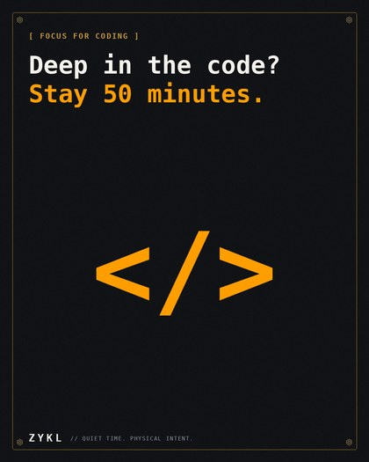  Slide 1: 03_coding_1_cover.png | 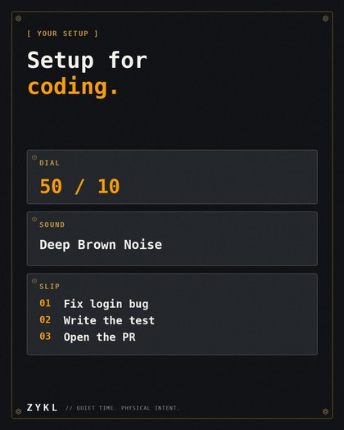  Slide 2: 03_coding_2_setup.png | 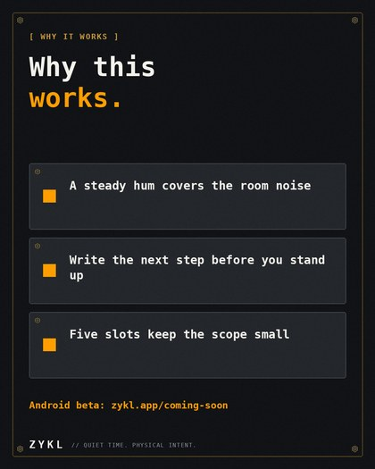  Slide 3: 03_coding_3_why.png
ENGLISH  Coding session setup I'd try.  Preset: 50/10. Sound: Deep Brown Noise (a steady rumble that blocks out a room). Slip: 'Fix login bug', 'Write the test', 'Open the PR'.  When the timer ends, write the next step before you stand up. Future you will skip the 15-minute warm-up.  Devs: what's your focus ritual? | BAHASA INDONESIA  Setelan sesi coding yang akan kucoba.  Preset: 50/10. Suara: Deep Brown Noise (gemuruh stabil yang meredam ruangan). Slip: 'Perbaiki bug login', 'Tulis test', 'Buka PR'.  Saat timer berakhir, tulis langkah berikutnya sebelum berdiri. Dirimu besok tidak perlu pemanasan 15 menit.  Dev: apa ritual fokusmu?
VIDEO TO ADD (FIRST ITEM OF THE CAROUSEL)
Select 50/10. Load Deep Brown Noise from the record drawer. Add 'Fix login bug', 'Write the test', 'Open the PR' and stamp one done. End on the dial running.
TIP
Your hello post drew a lot of developers, so this one should land well.
EN 307 / ID 304 characters (limit 500). Images: images/personal-usecases/en and /id

Post 3: Studying and assignments
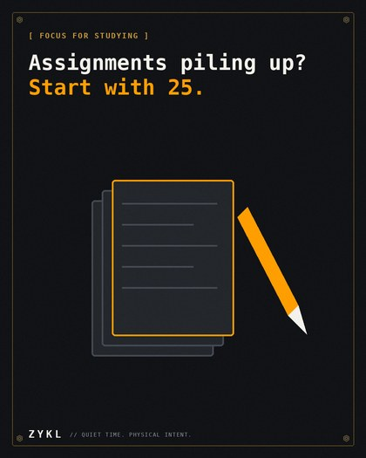  Slide 1: 02_study_1_cover.png | 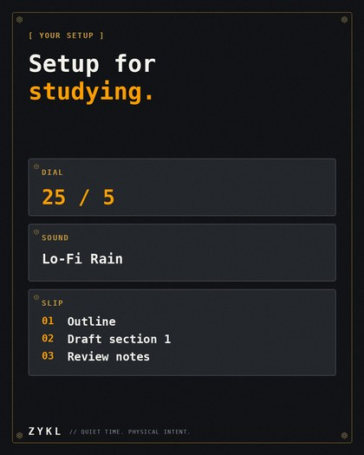  Slide 2: 02_study_2_setup.png | 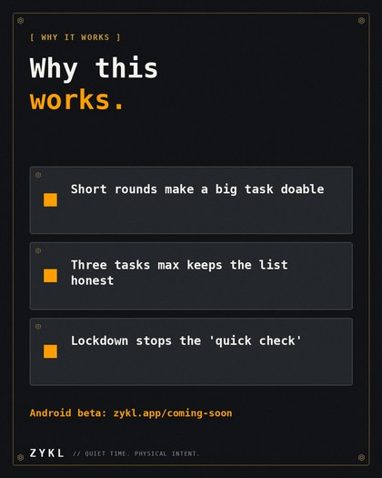  Slide 3: 02_study_3_why.png
ENGLISH  Assignments piling up? Try this.  Preset: 25/5. Sound: Lo-Fi Rain. Slip: 3 tasks max, like 'Outline', 'Draft section 1', 'Review notes'.  Turn on Lockdown so the phone can't pull you away. Hold 5 seconds if you really have to leave.  Students: what's the hardest part of starting? | BAHASA INDONESIA  Tugas menumpuk? Coba ini.  Preset: 25/5. Suara: Lo-Fi Rain. Slip: maksimal 3 tugas, misalnya 'Kerangka', 'Tulis bagian 1', 'Cek catatan'.  Nyalakan Lockdown supaya ponsel tidak menarikmu pergi. Tahan 5 detik kalau memang harus keluar.  Buat para pelajar: bagian tersulit untuk mulai itu apa?
VIDEO TO ADD (FIRST ITEM OF THE CAROUSEL)
Select 25/5, load Lo-Fi Rain, add three tasks, then tap Lockdown. Show the 5-second hold to unlatch.
TIP
Students are a big audience for focus timers. Reply to every 'hardest part' answer.
EN 280 / ID 291 characters (limit 500). Images: images/personal-usecases/en and /id

Post 4: Reading a book
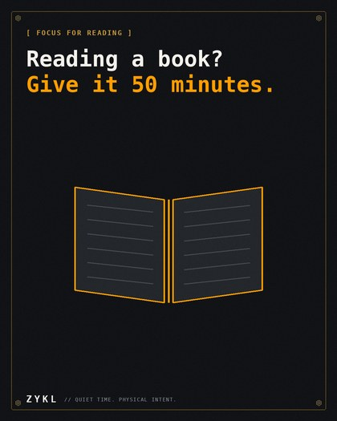  Slide 1: 01_reading_1_cover.png | 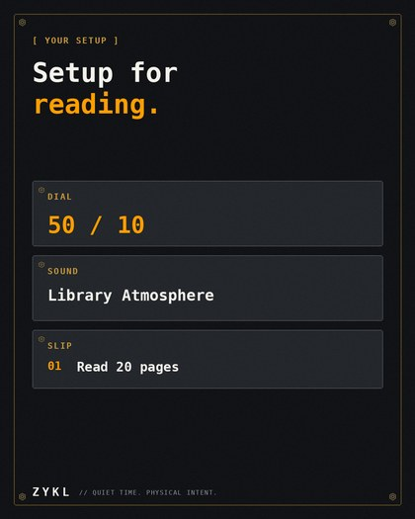  Slide 2: 01_reading_2_setup.png | 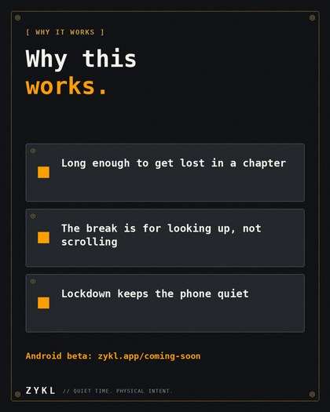  Slide 3: 01_reading_3_why.png
ENGLISH  Reading a book? Try this setup.  Preset: 50/10. Sound: Library Atmosphere (a quiet reading room, pages turning). Slip: 'Read 20 pages'.  Fifty minutes is long enough to get lost in a chapter, and the 10-minute break is for looking up, not scrolling.  What are you reading right now? | BAHASA INDONESIA  Lagi baca buku? Coba setelan ini.  Preset: 50/10. Suara: Library Atmosphere (ruang baca yang sepi, suara halaman dibalik). Slip: 'Baca 20 halaman'.  Lima puluh menit cukup lama untuk tenggelam dalam satu bab, dan istirahat 10 menit untuk mengangkat kepala, bukan untuk scroll.  Sekarang kamu lagi baca apa?
VIDEO TO ADD (FIRST ITEM OF THE CAROUSEL)
Select 50/10, load Library Atmosphere, add 'Read 20 pages'. A great shot: the phone propped beside a real book while the dial ticks.
TIP
'What are you reading?' is an easy question, so expect many replies.
EN 282 / ID 306 characters (limit 500). Images: images/personal-usecases/en and /id

Post 5: Writing
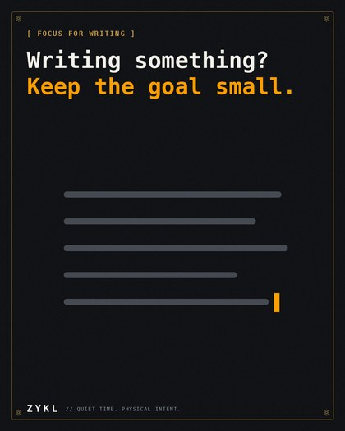  Slide 1: 04_writing_1_cover.png | 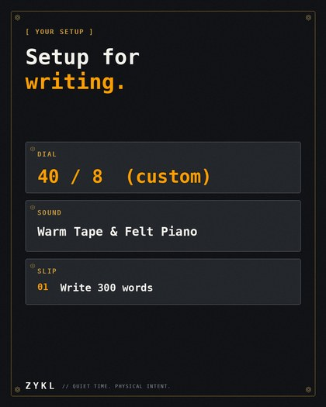  Slide 2: 04_writing_2_setup.png | 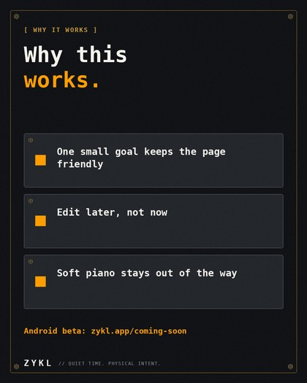  Slide 3: 04_writing_3_why.png
ENGLISH  Writing something? Here's a setup for it.  Preset: custom, 40 minutes focus and 8 break. Sound: Warm Tape & Felt Piano. Slip: 'Write 300 words' and nothing else.  One small goal keeps the blank page friendly. Edit later, not now.  What are you writing at the moment? | BAHASA INDONESIA  Lagi menulis? Ini setelan untuknya.  Preset: custom, 40 menit fokus dan 8 menit istirahat. Suara: Warm Tape & Felt Piano. Slip: 'Tulis 300 kata' dan tidak ada yang lain.  Satu target kecil membuat halaman kosong terasa ramah. Edit nanti, bukan sekarang.  Sekarang kamu lagi menulis apa?
VIDEO TO ADD (FIRST ITEM OF THE CAROUSEL)
Pull the crown to set 40 minutes (this is the best clip for it), load Warm Tape & Felt Piano, add 'Write 300 words'.
TIP
The crown-setting moment shows off the custom preset.
EN 266 / ID 286 characters (limit 500). Images: images/personal-usecases/en and /id

Post 6: Design and creative work
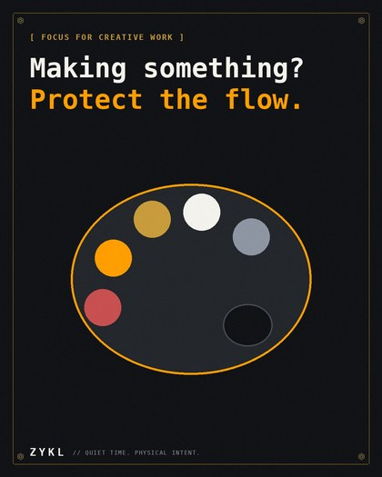  Slide 1: 05_creative_1_cover.png | 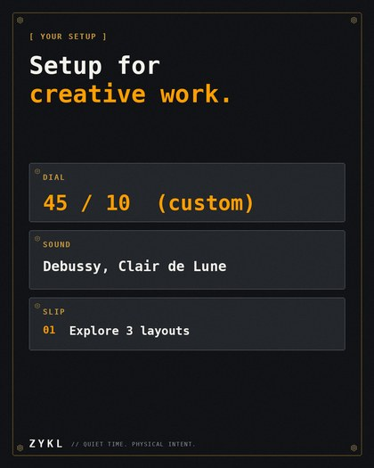  Slide 2: 05_creative_2_setup.png | 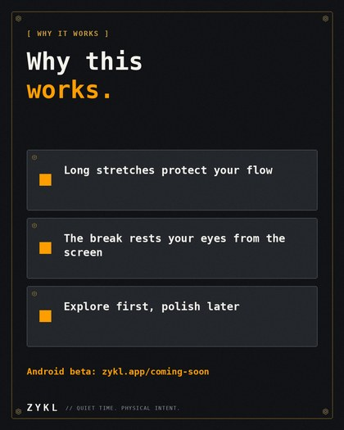  Slide 3: 05_creative_3_why.png
ENGLISH  For design and other creative work, I'd try this.  Preset: custom, 45 minutes focus and 10 break. Sound: Debussy, Clair de Lune (solo piano). Slip: 'Explore 3 layouts'.  Long stretches protect your flow, and the break lets your eyes rest from the screen.  What do you make? | BAHASA INDONESIA  Untuk desain dan kerja kreatif lain, ini yang akan kucoba.  Preset: custom, 45 menit fokus dan 10 menit istirahat. Suara: Debussy, Clair de Lune (piano solo). Slip: 'Eksplor 3 layout'.  Waktu yang panjang menjaga alirmu, dan jeda memberi matamu istirahat dari layar.  Kamu membuat apa?
VIDEO TO ADD (FIRST ITEM OF THE CAROUSEL)
Set 45 minutes with the crown, switch to a lighter edition (for example Atelier Cream) to show the look, load Clair de Lune.
TIP
Changing the edition on camera shows the material finishes, which creatives love.
EN 273 / ID 285 characters (limit 500). Images: images/personal-usecases/en and /id

Post 7: Learning a language
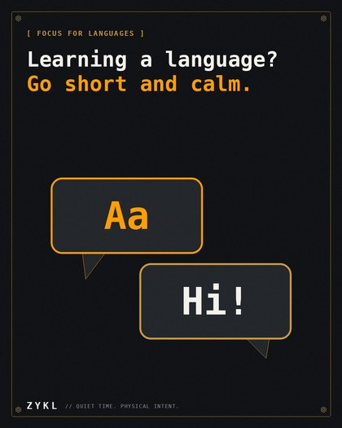  Slide 1: 06_language_1_cover.png | 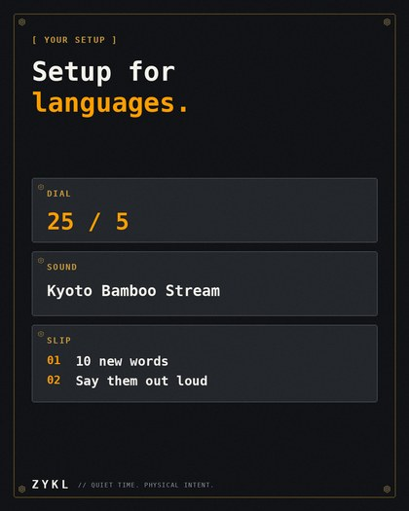  Slide 2: 06_language_2_setup.png | 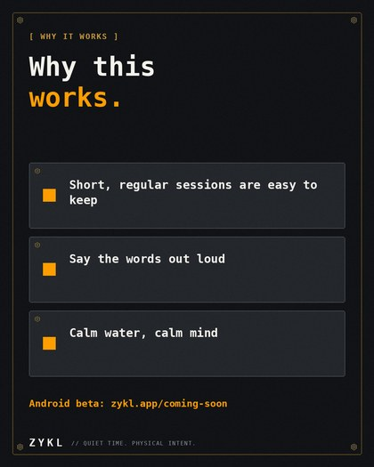  Slide 3: 06_language_3_why.png
ENGLISH  Learning a language in short, calm bursts.  Preset: 25/5. Sound: Kyoto Bamboo Stream (water trickling through a stone garden). Slip: '10 new words' and 'Say them out loud'.  Short, regular sessions are easier to keep up than one long weekend cram.  Which language are you learning? | BAHASA INDONESIA  Belajar bahasa dalam sesi singkat yang tenang.  Preset: 25/5. Suara: Kyoto Bamboo Stream (air mengalir di taman batu). Slip: '10 kata baru' dan 'Ucapkan keras-keras'.  Sesi singkat yang rutin lebih mudah dijaga daripada ngebut satu akhir pekan panjang.  Kamu sedang belajar bahasa apa?
VIDEO TO ADD (FIRST ITEM OF THE CAROUSEL)
Select 25/5, load Kyoto Bamboo Stream, add the two tasks. Film a notebook with vocabulary beside the phone.
TIP
'Which language?' invites many different answers, so reply to each.
EN 281 / ID 285 characters (limit 500). Images: images/personal-usecases/en and /id

Post 8: Admin and chores
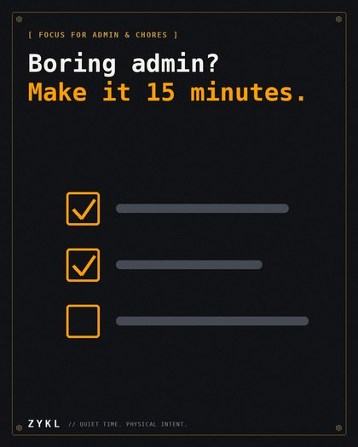  Slide 1: 07_admin_1_cover.png | 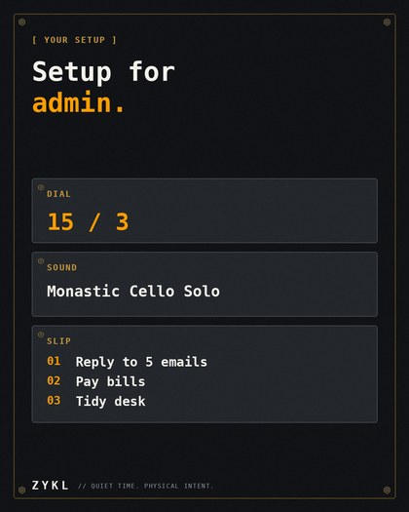  Slide 2: 07_admin_2_setup.png | 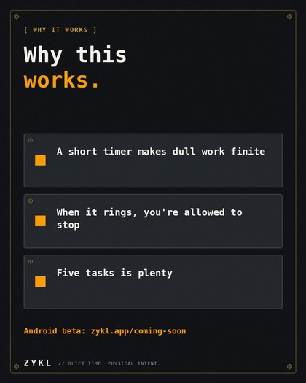  Slide 3: 07_admin_3_why.png
ENGLISH  Boring admin or chores? Make them a 15-minute game.  Preset: 15/3. Sound: Monastic Cello Solo (Bach). Slip: 'Reply to 5 emails', 'Pay bills', 'Tidy desk'.  A short timer makes the dull stuff feel finite. When it rings, you're allowed to stop.  What are you putting off today? | BAHASA INDONESIA  Urusan administrasi atau beres-beres yang membosankan? Jadikan permainan 15 menit.  Preset: 15/3. Suara: Monastic Cello Solo (Bach). Slip: 'Balas 5 email', 'Bayar tagihan', 'Rapikan meja'.  Timer pendek membuat hal yang membosankan terasa terbatas. Saat berdering, kamu boleh berhenti.  Apa yang lagi kamu tunda hari ini?
VIDEO TO ADD (FIRST ITEM OF THE CAROUSEL)
Select 15/3, load Monastic Cello Solo, add the three tasks, stamp them one by one. The stamp sound is satisfying here.
TIP
Relatable and a little funny, which is good for sharing.
EN 275 / ID 321 characters (limit 500). Images: images/personal-usecases/en and /id

4. Recording guide for your real videos
You said you'll add real screen recordings. The images set up each post, and a 15 to 25 second recording shows the app doing it.

Every video, same skeleton
- Open on the Dial tab and pick the preset (or pull the crown for a custom length).
- Switch to the Vinyl tab, open the record drawer, and load the soundscape. The stylus-drop sound is a nice moment.
- Switch to the Tasks tab, add one to three tasks, and stamp one done.
- Optional: engage Lockdown and show the 5-second hold.
- End on the Dial with the hand ticking, and hold that shot for two seconds.

Technical tips
- Turn on Do Not Disturb before recording so no notification pops up on screen.
- Check that your recorder captures the app's sound. Many Android screen recorders have an 'internal audio' option. Test a 5-second clip first.
- Record in portrait, in dark theme to match the images. Keep the phone's status bar clean, and avoid showing personal details.
- Trim to 15 to 25 seconds. Cut any dead time between taps.
- Add a short on-screen caption in your editor (for example 'Reading: 50/10 + Library Atmosphere'), because many people watch without sound at first.

Shot list per activity
Activity | Preset | Sound to load | Tasks to add | Extra shot
Reading | 50/10 | Library Atmosphere | Read 20 pages | Phone beside a real book
Studying | 25/5 | Lo-Fi Rain | Outline, Draft section 1, Review notes | Lockdown engaged and the 5-second hold
Coding | 50/10 | Deep Brown Noise | Fix login bug, Write the test, Open the PR | Laptop with an editor behind the phone
Writing | Crown to 40 | Warm Tape & Felt Piano | Write 300 words | Crown being pulled
Creative | Crown to 45 | Debussy, Clair de Lune | Explore 3 layouts | Switch to a lighter edition
Languages | 25/5 | Kyoto Bamboo Stream | 10 new words, Say them out loud | Notebook with vocabulary
Admin | 15/3 | Monastic Cello Solo | Reply to 5 emails, Pay bills, Tidy desk | Stamp each task done

5. Rules and checklist
- Don't promise results ('you'll finish twice as fast'). Say what you'd try and why.
- The Lockdown line says you hold for 5 seconds to leave. Keep that wording exactly.
- The app screens show 'BRAUN' labels. Your launch plan flags that as a trademark risk, so fix it before you record.
- Beta posts: mention the Android beta only while spots are open.
- Keep the closing question in every post, and reply to the answers in the first hour.

